1) Write a command that puts following values, in their given order, into the salespeople table:
City - San Jose , Name – Blanco, Comm – Null , Cnum – 1100.

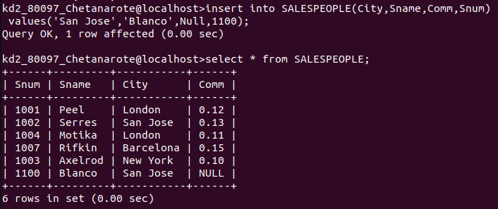

2) Write a command that removes all orders from Customer Clemens from the Orders table.

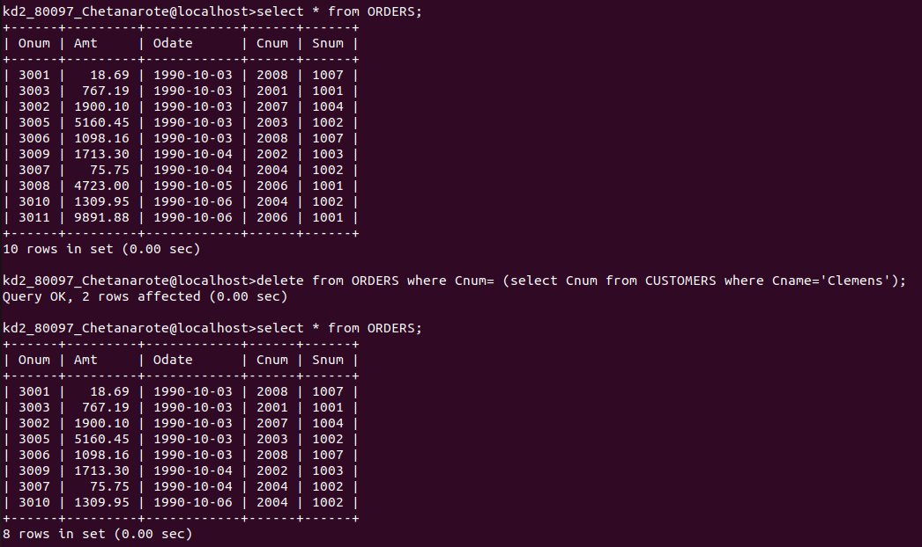

3) Write a command the increases the rating of all customers in Rome by 100.

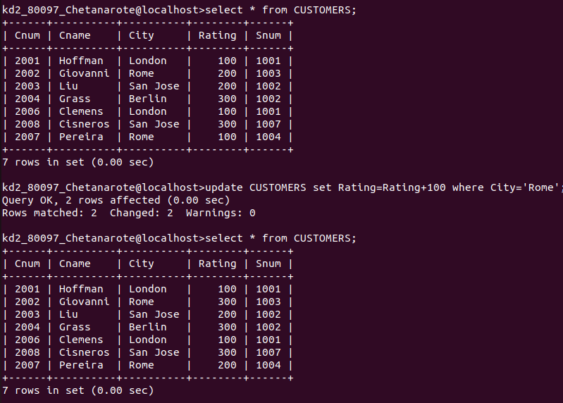
4)Salesperson Serres has left the company. Assign her customers to Motika.

